**User Guide**

Contents

1. Tours

1.1. Adding a new tour to the system............................................................................................... 2

1.2. Editing an existing tour............................................................................................................. 3

1.3. Removing an existing tour from the system............................................................................. 4

2. Chauffeurs

2.1. Adding a new Chauffeur to the system..................................................................................... 4

2.2. Editing a Chauffeur’s information............................................................................................ 5

2.3. Removing a Chauffeur from the system................................................................................... 5

3. Reservations

3.1. Making a reservation for a trip or journey................................................................................ 6

3.2. Making a reservation for a Bus-and-Chauffeurs....................................................................... 7

3.3. Editing an existing reservation.................................................................................................. 8

3.4. Removing a reservation from the system.................................................................................. 9

4. Customer

4.1. Adding a customer to the system........................................................................................... 10

4.2. Editing a customer’s information............................................................................................ 10

4.3. Removing a customer from the system................................................................................... 11

5. Busses – change number of available busses.......................................................................................... 11

1. Tours

**1.1. Adding a new tour to the system**

1. Select “Tours” tab from the top part of the window.

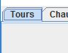

2. Fill out all the fields with the correct information : ‘Departure Location’ is the place where the tour starts and ‘Arrival Location’ is where the tour will end. In the ‘Stops’ field enter all the stops on the route (ex: Berlin, Budapest). Enter the departure time and arrival time in the dd/mm/yyyy format (ex: 10/12/2016). After that a bus may be selected from the dropdown list.

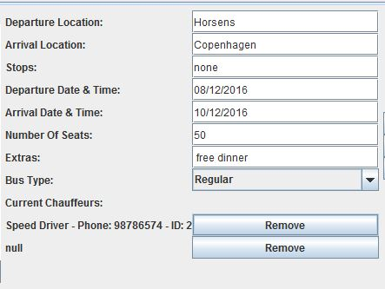

3. Press “Add” button to add the new tour to the system.

4. Select the created tour from the list on the left and select up to two available chauffeurs from the Available Chauffeurs list and pressing ‘Add Chauffeur’ button afterwards.

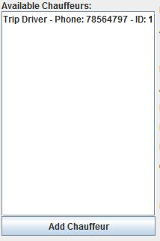

**1.2 Editing an existing tour**

1. Select “Tours” tab from the top part of the window.



2. Select a tour from the Tours list shown on the left side of the window.

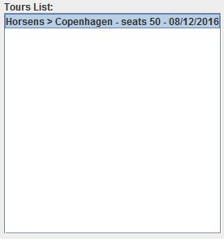

3. The data fields in the middle part will be updated after selecting a Tour and you are able to edit them. Also you can remove the current chauffeurs of the tour or add more chauffeurs from the Available Chauffeurs list.



4. After editing the Tour’s information, press ‘Save’ to update that Tour’s information in the system.

**1.3 Removing a tour from the system**

1. Select “Tours” tab from the top part of the window.



2. Select a tour from the Tours list shown on the left side of the window.



3. Press the ‘Remove’ button to remove the selected tour from the system.

2. Chauffeurs

**2.1. Adding a new Chauffeur to the system**

1. Select “Chauffeurs” tab from the top part of the window.



2. Fill out all the fields with the correct information : Name (first name and last name), Phone Number (all formats supported), Select from the dropdown list which employment type fits the new chauffeur (Full-Time or Part-Time), Employee ID and Preferences of the chauffeur.

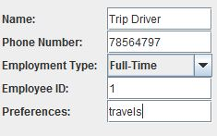

3. Press “Add” button to add the new chauffeur to the system.

**2.2 Editing a Chauffeur’s information**

1. Select “Chauffeurs” tab from the top part of the window.

C:\Users\Sebastian\AppData\Local\Microsoft\Windows\INetCache\Content.Word\chatab.jpg

2. Select a chauffeur from the chauffeurs list shown on the left side of the window.

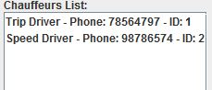

3. The data fields in the middle part will be updated after selecting a chauffeur and you are able to edit them.



4. After editing the chauffeur’s information, press ‘Save’ to update that chauffeur’s information in the system.

**2.3 Removing a Chauffeur from the system**

1. Select “Chauffeurs” tab from the top part of the window.

C:\Users\Sebastian\AppData\Local\Microsoft\Windows\INetCache\Content.Word\chatab.jpg

2. Select a chauffeur from the chauffeurs list shown on the left side of the window.



3. Press the ‘Remove’ button to remove the selected chauffeur from the system.

3. Reservation

**3.1. Making a reservation for a trip or journey**

1. Select “Reservations” tab from the top part of the window.

2. Select “Trip & Journey” tab below the previously selected tab.

C:\Users\Sebastian\AppData\Local\Microsoft\Windows\INetCache\Content.Word\res1.jpg

3. Select a trip or a journey from the list located on the left side of the window.

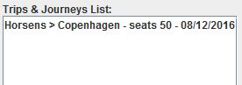

4. Fill out all the fields in middle part of the window with the correct information : Customer’s Name, his Address and Phone Number (E-Mail if necessary), the number of seats to reserve, the customer’s preferences and the reservation price. Also all the other’s passenger’s information will have to be inserted in the next empty fields under “Add passengers to reservation” and to press ‘Add Passenger’ for each passenger.

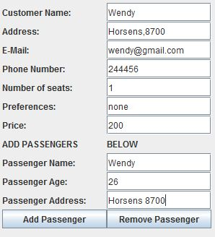

5. Press “Create” button to create the new reservation and to save it in the system.

**3.2. Making a reservation for a Bus-and-Chauffeur**

1. Select “Reservations” tab from the top part of the window.

2. Select “Bus-and-Chauffeur” tab below the previously selected tab.



3. Fill out all the fields in middle part of the window with the correct information : Customer’s name, their address, phone number, email (if necessary), preferences and reservation price. Then you should insert the data about the actual tour: Departure location, Arrival location, Stops, Departure date and time, Arrival date and time.

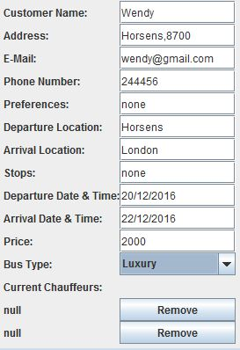

3. Press “Create Reservation” button to create the new Bus-and-Chauffeur reservation and save it in the system. After creating the reservation you may select it from the list and set up to two chauffeurs from the Available Chauffeurs list by pressing ‘Add Chauffeur’.



**3.3. Editing an existing reservation**

1. Select “Reservations” tab from the top part of the window.

2. Select “Trips & Journeys” tab or “Bus-and-Chauffeur” tab below the previously selected tab.

C:\Users\Sebastian\AppData\Local\Microsoft\Windows\INetCache\Content.Word\res1.jpg OR C:\Users\Sebastian\AppData\Local\Microsoft\Windows\INetCache\Content.Word\res4.jpg

3. Select a reservation from the reservations list shown on the left side of the window.

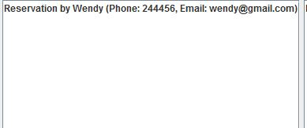

4. The data fields in the middle part will be updated after selecting a reservation and you are able to edit them.

 OR 

4. After editing the reservation, press ‘Save’ to update that reservation’s information in the system.

**3.4. Removing a reservation from the system**

1. Select “Reservations” tab from the top part of the window.

2. Select “Trips & Journeys” tab or “Bus-and-Chauffeur” tab below the previously selected tab.

C:\Users\Sebastian\AppData\Local\Microsoft\Windows\INetCache\Content.Word\res1.jpg OR C:\Users\Sebastian\AppData\Local\Microsoft\Windows\INetCache\Content.Word\res4.jpg

3. Select a reservation from the reservations list shown on the left side of the window.



4. Press the ‘Remove’ button to remove the selected reservation from the system.

4. Customer

**4.1. Adding a new Customer to the system**

1. Select “Customers” tab from the top part of the window.



2. Fill out all the fields with the correct information : Customer’s name, their address, phone number, email (if necessary)

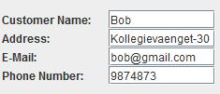

3. Press “Add” button to add the new customer to the system.

**4.2 Editing a Customer’s information**

1. Select “Customers” tab from the top part of the window.

C:\Users\Sebastian\AppData\Local\Microsoft\Windows\INetCache\Content.Word\cust1.jpg

2. Select a customer from the customers list shown on the left side of the window.

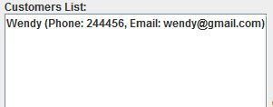

3. The data fields in the middle part will be updated after selecting a customer and you are able to edit them.



4. After editing the customer’s information, press ‘Save’ to update that customer’s information in the system.

**4.3 Removing a Customer from the system**

1. Select “Customers” tab from the top part of the window.

C:\Users\Sebastian\AppData\Local\Microsoft\Windows\INetCache\Content.Word\cust1.jpg

2. Select a customer from the customers list shown on the left side of the window.



3. Press the ‘Remove’ button to remove the selected customer from the system.

5. Busses

1. Select the “Busses” tab from the top of the window.

C:\Users\Sebastian\AppData\Local\Microsoft\Windows\INetCache\Content.Word\bus1.jpg

2. Modify the existing number of available busses for each capacity category.

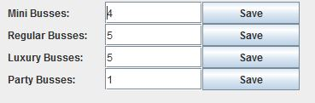

3. Press ‘Save’ button for the category that you changed.